
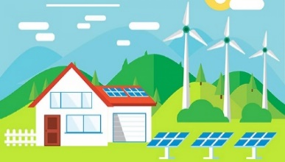
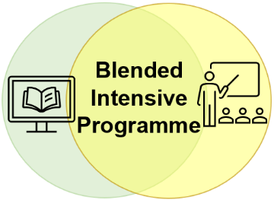
PHYSICS OF RENEWABLE ENERGY SOURCES
USED IN HOUSEHOLDS
Aim: study of the physical phenomena in the renewable energy resources used in households
Week 1  on-line  10-14 October 2022 | Week 2  ALYTAUS KOLEGIJA/University Applied Sciences  (Alytus, Lithuania)  17-21 October 2022
Virtual activities  MS TEAMS platform  - Introduction  - Solar energy  - Wind energy  - Geothermal energy  - Bioenergy | Real activities  Laboratory work  - Alytus Regional Technology Centre  - Alytus STEAM Open Access Centre  How renewable energy resources are applied in Lithuanian households/ Field visit  - Lithuanian Energy Institute in Kaunas  Cultural programme  Education programme at Alytus Ethnographic Museum  Swimming pool of Alytus Sports & Recreation Centre  Bowling, billiard
Acquired knowledge and skills:
- Learn about the strategies for the use of renewable energy resources in different countries
- Identify the types of the renewable energy resources used in households
- Recognize the physical phenomena in the environment of renewable energy resources
- Explain the physical phenomena using the basic concepts and laws of physics.
Value: 3 ECTS
Your team: 5 students and a teacher (4 teams from 4 different countries)
Duration: 2 weeks: from 10 to 21 October 2022
Contact: birute.rakauskiene@akolegija.lt

