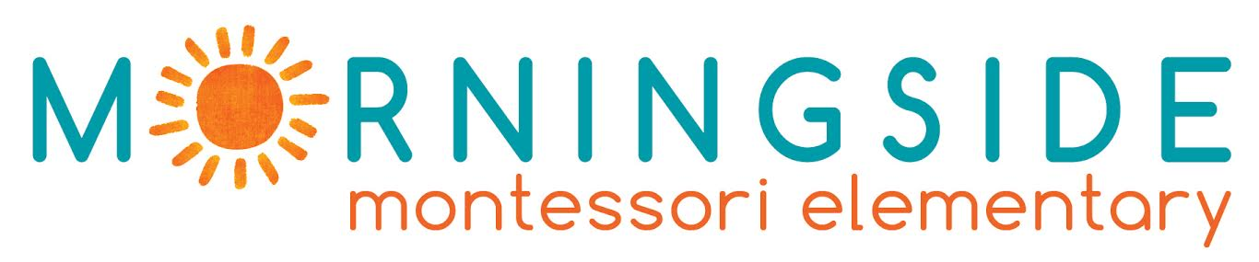

ERASMUS PLACEMENT OFFER

EMPLOYER INFORMATION
Name of the Organization | Morningside Montessori Elementary Private School
Address | Dorieon 20, Ayios Andreas
Postal Code | 1101
City | Nicosia , Cyprus
Telephone | +35799319536
Facebook page | https://www.facebook.com/MorningsideCyprus/
Morningside at a Glance | Morningside Montessori is going to be the first elementary in Cyprus to follow the Montessori Method, as well as the first trilingual school on the island, starting September 2017.  Morningside Montessori Elementary is a non-profit company with founding members from the fields of Montessori education, developmental psychology, psychoanalysis, sociology, anthropology, peace education, architecture, and business administration and accounting.  Our learning environment, which is not bound within the classroom, is hands-on and child-directed. We aim to educate the whole child through a comprehensive Montessori education that cultivates outdoor learning, self-directed action, flexible thinking, creativity, and non-standardized models of problem-solving.  We believe that we must embrace each other with empathy, in order to promote a culture of peace and understanding. It is for this reason that it is imperative to learn and understand each other’s language. In order to bring the two larger communities of the island of Cyprus together, both Greek and Turkish are taught to students.  Morningside Montessori is in the process of accreditation by the Cyprus Ministry of Education and Culture.

CONTACT DETAILS
Contact Person (s) | Evi Eftychiou / Angeliki Yiassemides
Title | Directors
Direct Telephone Number | +35799319536 / +35799972237
Direct Email Address | evi@morningsidecyprus.com  angeliki@morningsidecyprus.com

PLACEMENT INFORMATION
Description of Activities | Administrative officer:  - Organize, coordinate and participate in the summer school activities  - Assist in the preparation of educational material  - Maintain and update school archives  - Dealing with correspondence  - Assist in setting up the school that will operate in September  - Assist in fundraising activities, festivals and events to be organized by the school
Skills and Personal Qualities | -creative flair  - strong organizational skills  -originality  -strong computer skills  -confidence, to present and explain ideas  -the ability to balance work on several projects at a time  -flexibility
Duration | Minimum 3 months – max 12 months
Working Hours | Approximately 30-40 Hours per week
Help with finding Accommodation | YES ( we can provide a list with possible flats or rooms for rent)

REQIUREMENTS
Excellent English language skills | Candidate must be able to communicate in English and preferably in Greek.  Applications from students who do not speak Greek will be accepted and considered.
Eligible to apply | Graduate Students Or Undergraduate students in:  - Education  - Social Sciences and Humanities  - Law  - Sciences  - Business  Priority will be given to candidates who study Education related subjects.
Required Documents | -CV  -Motivational Letter /email | - Proof of your English Language knowledge  -Copy of your Bachelor (if any) or any other Diploma
Please send your relevant document in this email: evi@morningsidecyprus.com
Deadline: 15th of January 2022

